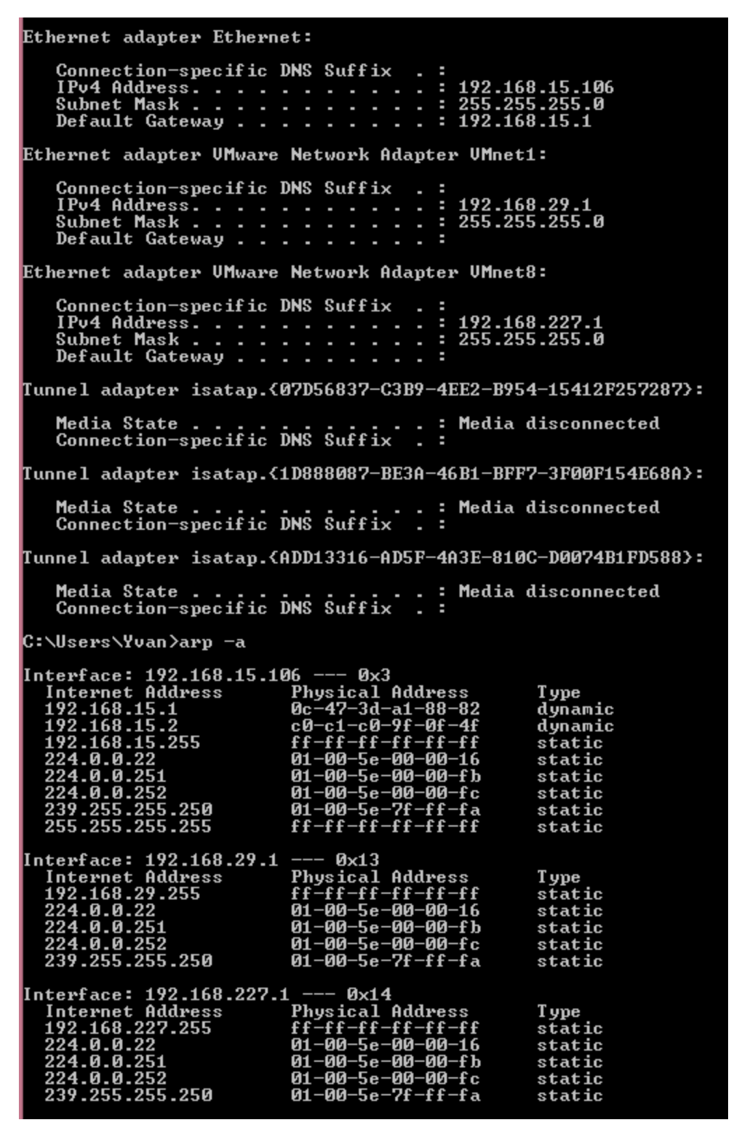
Question 1: Examine and analyse the output of the arp -a and ipconfig shown in the exhibit above to answer the following question. Note that both commands were run on the same device having IP 192.168.15.106.
What is the default gateway's MAC address:_____________
Answer NA if it is impossible to tell from the information provided.
Use colon : between every two hexadecimal digits (e.g. 2b:fa:24:65:ab:d6) 0c:47:3d:a1:88:82
Question 2: Examine and analyse the output of the arp -a and ipconfig shown in the exhibit above to answer the following question. Note that both commands were run on the same device having IP address 192.168.15.106.
What is the frame's destination MAC address if you are sending a message from 192.168.15.106 to a device located on a remote network segment: ____________
Answer NA if it is impossible to tell from the information provided.
Use colon : between every two hexadecimal digits (e.g. 2b:fa:24:65:ab:d6) 0c:47:3d:a1:88:82
Question 3: Examine and analyse the output of the arp -a and ipconfig shown in the exhibit above to answer the following question. Note that both commands were run on the same device having IP 192.168.15.106
What is the frame's destination MAC address if you are sending a message from 192.168.15.106 to 192.168.15.2:_____________________
Answer NA if it is impossible to tell from the information provided.
Use colon: between every two hexadecimal digits (e.g. 2b:fa:24:65:ab:d6) c0:c1:c0:9f:0f:4f

